Caroline Wachira

ICMP PING

Part 1_1 png

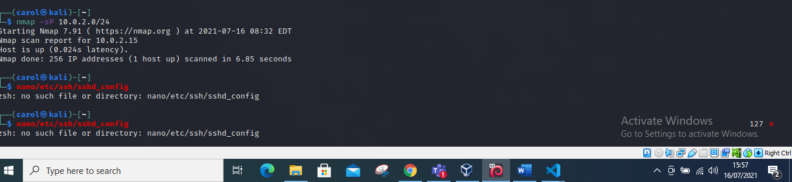

**TCP PING**

**To perform a TCP ping I input Nmap -sT and my network address which is 10.0.2.0/24 hence giving the command -sT 10.0.2.0/24**

Part 1.2 Png

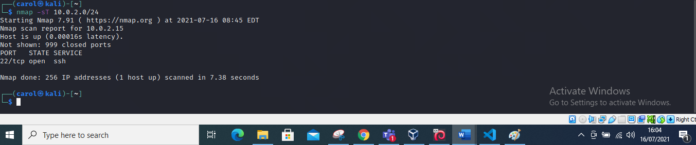

**TCP connect**

**I changed to being the root user so as to perform the tcp connect by writing “ SU” command then I input the command “ Nmap -sT -P 22, 10.0.2.0/24” to perform a TCP connect.**

Part 1.3 png

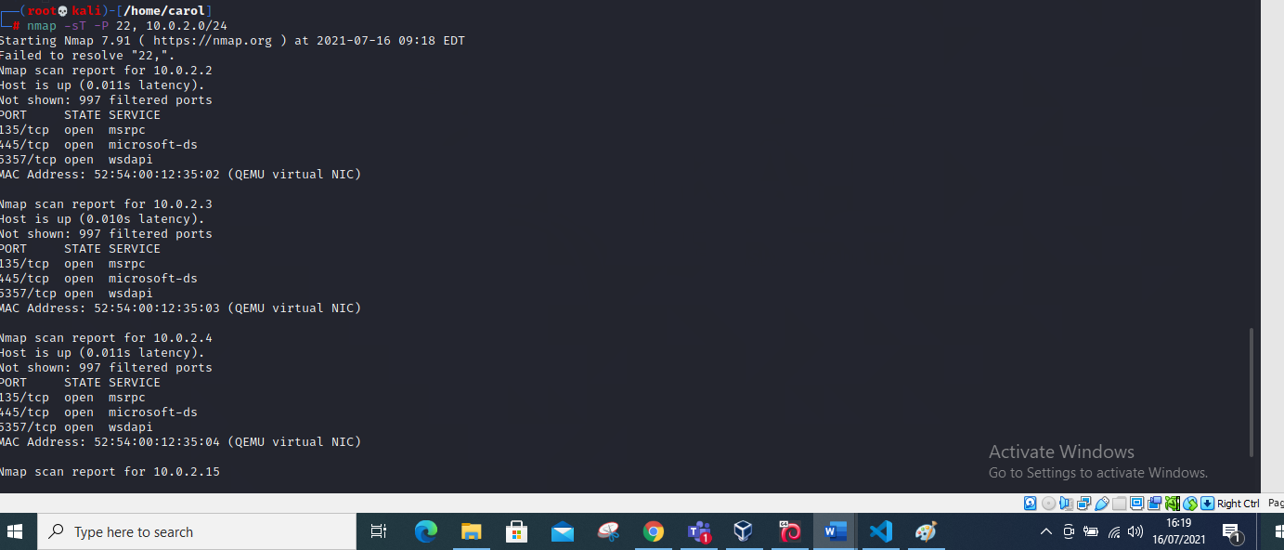

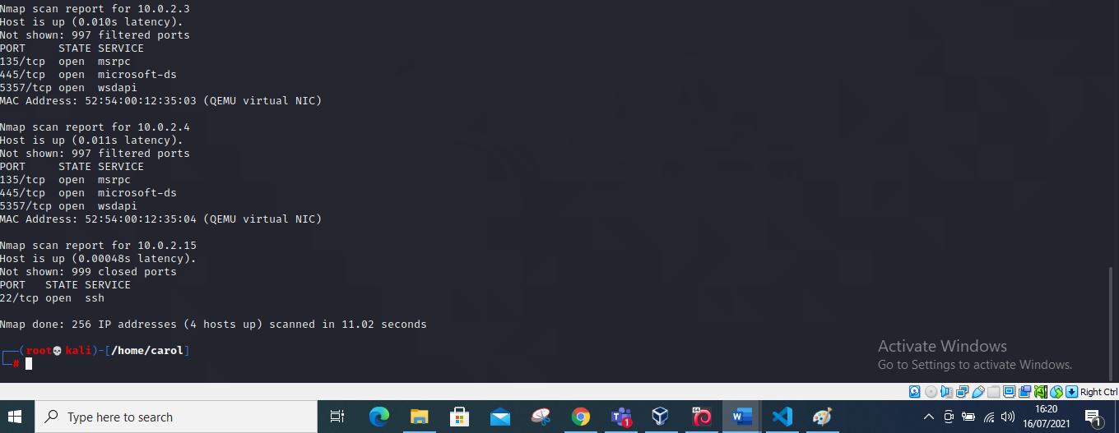

**PART 1.4 png**

**STEALTH SCANNING**

**We input the command “nmap -sS 10.0.2.15”this is my IP address**

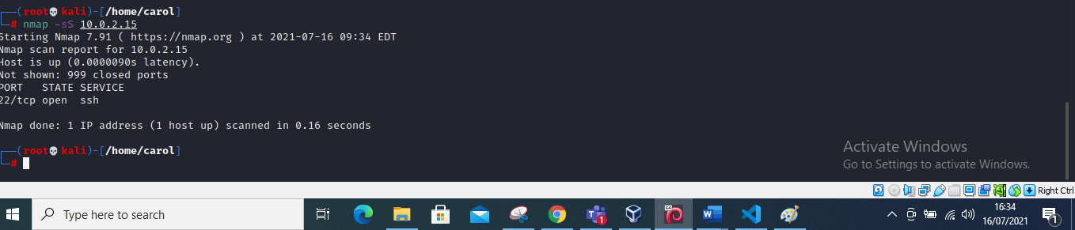

**PART 1.5 png**

**UDP SCANNING**

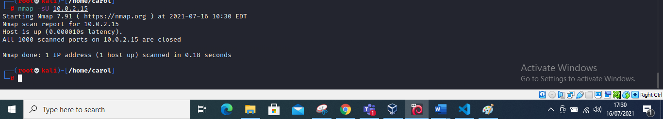

**Question 2**

Part 2.1png

A hacker leaked the below hash online. Can you crack it to know the password of the CEO? the flag is the password Hash: 06f8aa28b9237866e3e289f18ade19e1736d809d

The Password is: jrahyn+

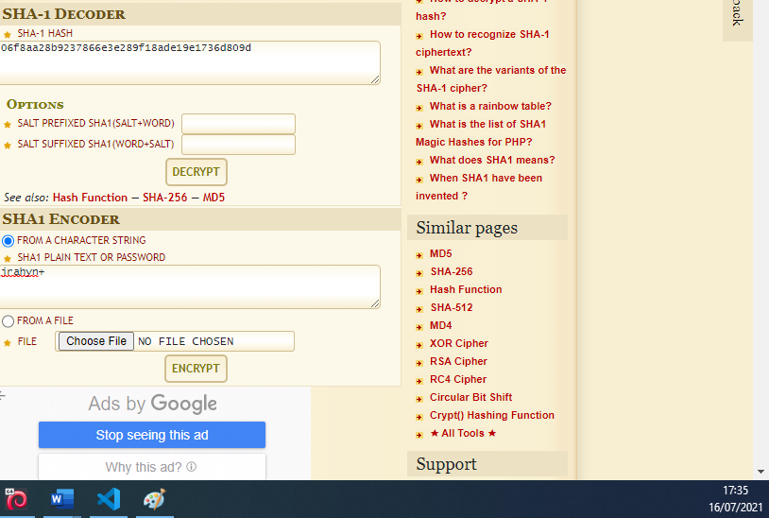

**Question 3**

**Part 3.1png**

1. Generate a RSA private key and save it to a file. The command you should be using is openssl genrsa

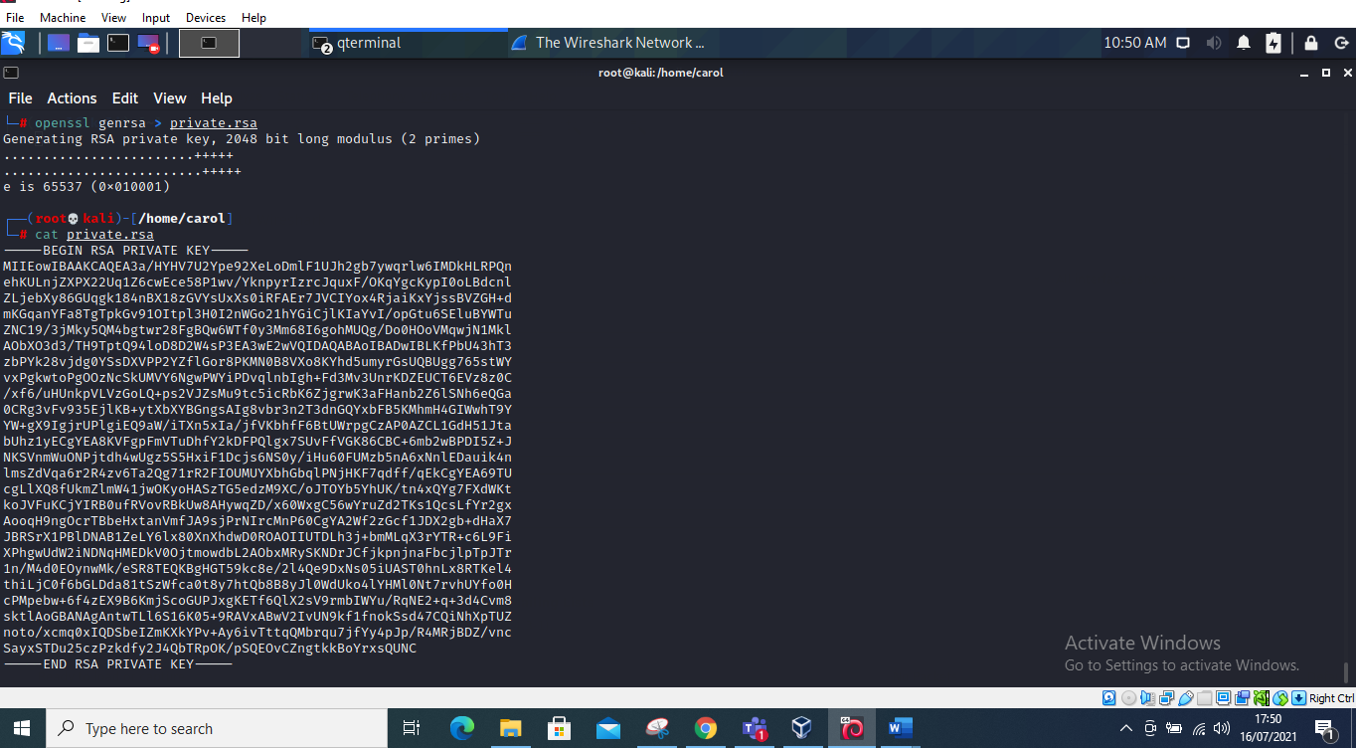

**Part 3.2png**

1. Generate and save a corresponding RSA public key. The command needed here is openssl rsa

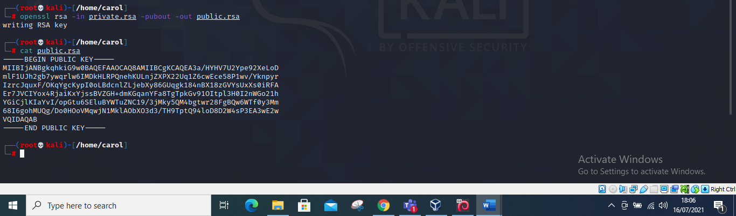

**Part 3.3png**

1. Encrypt a file using your RSA public key. The command needed is openssl rsautl

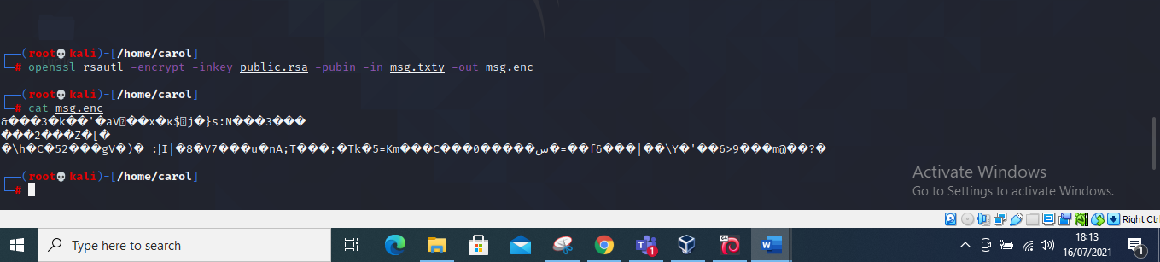

**Part 3.4png**

1. Decrypt the file using your RSA private key. Verify that the output matches the original.

